NAME: ____________________

Atmospheric carbon dioxide and Algebra II

I. Definitions and Background Information:

Part A: Modeling

A model is:

Examples of models are:

We use models because:

Part B: Carbon cycle

What processes increase carbon dioxide (CO₂) in the atmosphere?

What processes decrease carbon dioxide (CO₂) in the atmosphere?

Why does carbon dioxide (CO₂) in the atmosphere matter?

II. Modeling:

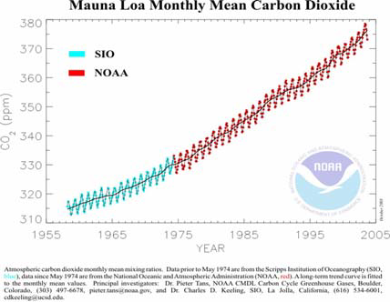

Years since 1960 | 0 | 10 | 20 | 30 | 40 | 50
CO₂ (parts per million) | 317 | 327 | 338 | 354 | 369 | 390

A portion of the Keeling curve of atmospheric CO₂ shown above can be modeled using the quadratic equation.

What is the quadratic equation?

Rewrite the quadratic equation using Years and CO₂ instead of x and y:

Pick three data points from the table. Solve a set of three simultaneous linear equations to determine the best-fit quadratic equation for this atmospheric data.

What is your prediction for the year (A) 2014? (B) 2050? (C) 2100?

What are the benefits of using this model?

What are the problems with using this model?

